EXPT NO: 6 | IMPLEMENTATION OF LSTM FOR SENTIMENT ANALYSIS
DATE: 28.09.2026 | IMPLEMENTATION OF LSTM FOR SENTIMENT ANALYSIS

PRE-LAB QUESTIONS (PROVIDE BRIEF ANSWERS TO THE FOLLOWING QUESTIONS)

- What is the purpose of Long Short-Term Memory (LSTM) networks in NLP?
LSTM networks are used in Natural Language Processing (NLP) to learn patterns and dependencies in sequential text data. They are a type of recurrent neural network designed to remember important information for longer periods while processing a sequence. In sentiment analysis, an LSTM processes words in a review sequentially and learns relationships between words. This helps the model classify text into sentiment categories such as positive or negative.

- Why is LSTM preferred over a Simple RNN for processing long text sequences?
LSTM is preferred over a Simple RNN for long text sequences because it can retain important information over longer time intervals. A Simple RNN may have difficulty remembering information from earlier parts of a long sequence due to the vanishing gradient problem. LSTM uses a memory cell and specialized gates to control which information should be stored, updated, or removed. Therefore, LSTM can better capture long-term dependencies in text such as movie reviews.

- What is sentiment analysis? Give two real-world applications.
Sentiment analysis is an NLP technique used to determine the emotional or opinion-based meaning of textual data. It commonly classifies text into categories such as positive and negative sentiments. In the experiment, sentiment analysis is applied to reviews so that an LSTM model can classify them based on their sentiment. Two real-world applications are analyzing customer opinions about products and analyzing movie reviews to determine whether viewers have positive or negative opinions.

- Explain the role of tokenization and padding in text preprocessing.
Tokenization and padding are important steps in preparing text for an LSTM model. Tokenization divides a sentence or review into individual words or tokens and converts these tokens into numerical values using a tokenizer. Padding is then used to make sequences of different lengths equal in size. This is necessary because neural networks generally require inputs with consistent dimensions. The experiment specifically includes tokenization, numerical sequence generation, and sequence padding before model training.

- What is word embedding? Why is it useful for sentiment analysis?
Word embedding is a method of representing words as dense numerical vectors that capture useful relationships between words. Instead of treating every word as an unrelated symbol, an embedding layer converts tokenized sequences into vector representations that can be processed by a neural network. In sentiment analysis, these representations help the LSTM learn relationships between words and their contextual information. The experiment uses a Keras/TensorFlow Embedding layer to generate dense representations of the preprocessed text.

AIM
To implement a Long Short-Term Memory (LSTM) network for sentiment analysis by performing text preprocessing, tokenization, sequence generation, and embedding using NLP libraries, and classify text into sentiment categories.

SOFTWARE REQUIREMENTS
- Python
- TensorFlow / Keras
- Google Colab
- GitHub
- NumPy
- Pandas
- Matplotlib
- NLP libraries – NLTK / spaCy
- Scikit-learn

OBJECTIVES
Students will be able to:
- Understand the architecture and working of LSTM networks.
- Perform text preprocessing techniques for sentiment analysis.
- Tokenize and convert textual data into numerical sequences.
- Generate word embeddings for textual data.
- Build and train an LSTM model for sentiment classification.
- Evaluate the performance of the trained LSTM model.
- Analyze the effect of preprocessing and embedding on sentiment classification.

PROCEDURE
PART A: DATASET PREPARATION AND TEXT PREPROCESSING
- Perform the following tasks:
- Load a sentiment analysis dataset such as the IMDB Movie Reviews dataset.
- Explore the dataset and examine sample positive and negative reviews.
- Check the number of samples and sentiment class distribution.
- Perform text preprocessing using NLP libraries.
- Convert text to lowercase.
- Remove unnecessary punctuation and special characters.
- Remove stop words, if required.
- Tokenize the reviews into words/tokens.
- Convert the tokens into numerical sequences using a tokenizer.
- Build a vocabulary from the training reviews.
- Apply sequence padding to obtain equal-length input sequences.
- Encode sentiment labels into numerical form.
- Split the prepared dataset into training and testing/validation datasets.
(CODE: CONATAINS STUDENT ROLL NOS
SCREENSHOT OF CODE
SCREENSHOT OF OUTPUT)

PART B: EMBEDDING GENERATION
Perform the following tasks:
- Generate numerical representations of the pre-processed text.
- Create an Embedding layer using Keras/TensorFlow.
- Define the vocabulary size and embedding dimension.
- Convert tokenized sequences into dense vector representations.
- Display the shape of the generated embedding representation.
- Analyze how words are represented in the embedding space.
(CODE: CONATAINS STUDENT ROLL NOS
SCREENSHOT OF CODE
SCREENSHOT OF OUTPUT)

PART C: IMPLEMENTING THE LSTM MODEL
Perform the following tasks:
- Create an input layer for the padded text sequences.
- Add an Embedding layer to generate dense word representations.
- Add an LSTM layer to learn sequential dependencies in the reviews.
- Add a Dense output layer with an appropriate activation function for sentiment classification.
- Compile the model using:
  - Appropriate optimizer
  - Binary cross-entropy loss
  - Accuracy as the evaluation metric
- Display the model architecture and summary.
(CODE: CONATAINS STUDENT ROLL NOS
SCREENSHOT OF CODE
SCREENSHOT OF OUTPUT)

PART D: MODEL TRAINING AND SENTIMENT PREDICTION
Perform the following tasks:
- Train the LSTM model using the prepared training dataset.
- Validate the model using the validation dataset.
- Record:
  - Training accuracy
  - Validation accuracy
  - Training loss
  - Validation loss
- Visualize:
  - Accuracy vs. Epoch
  - Loss vs. Epoch
- Evaluate the trained model using the test dataset.
- Predict the sentiment of sample reviews.
- Compare the predicted sentiment with the actual sentiment.
- Calculate appropriate evaluation metrics such as:
  - Accuracy
  - Precision
  - Recall
  - F1-score
  - Confusion matrix
(CODE: CONATAINS STUDENT ROLL NOS
SCREENSHOT OF CODE
SCREENSHOT OF OUTPUT)

EXPECTED OUTCOME
Students will understand how LSTM networks learn sequential information from textual data and apply them to sentiment classification. Students will learn to perform text preprocessing, tokenization, sequence padding, and embedding generation using NLP libraries. They will build and train an LSTM model and evaluate its ability to classify reviews into positive and negative sentiments.

CODE:

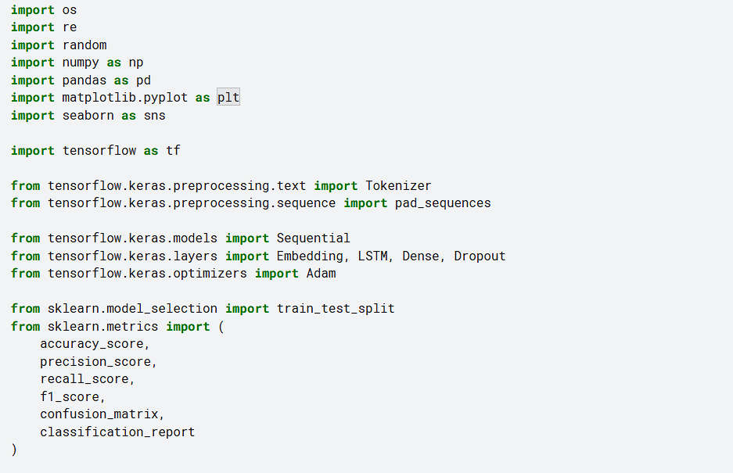
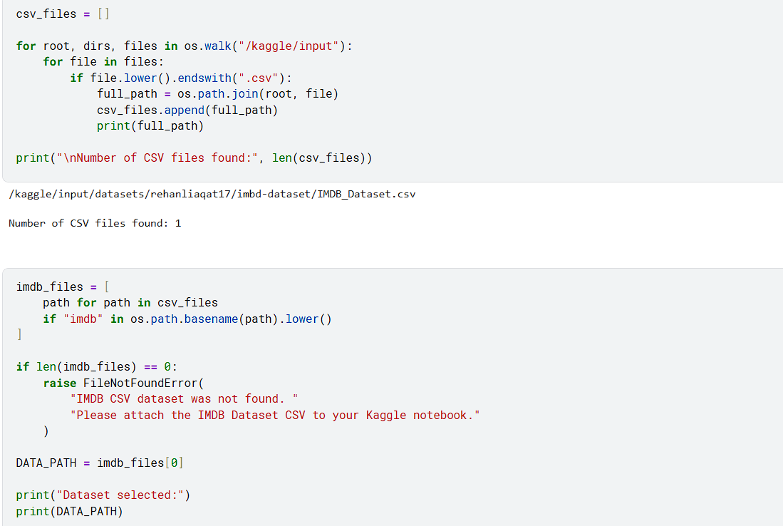
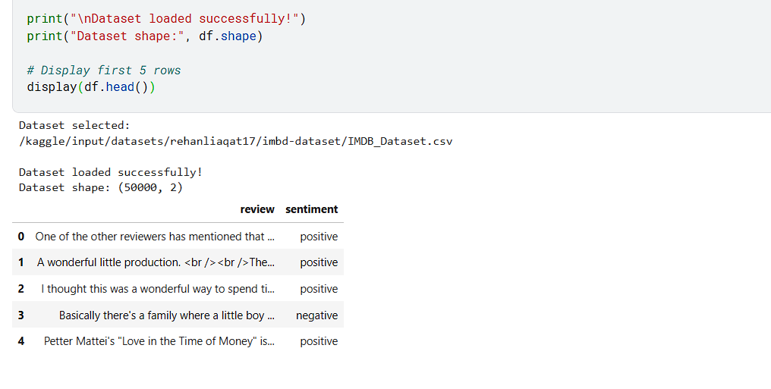
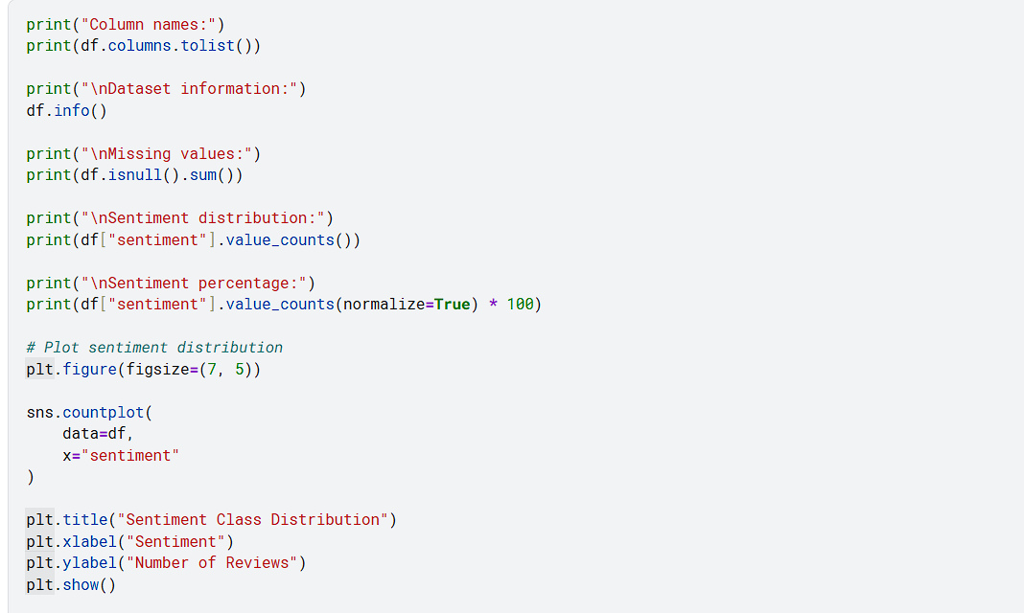
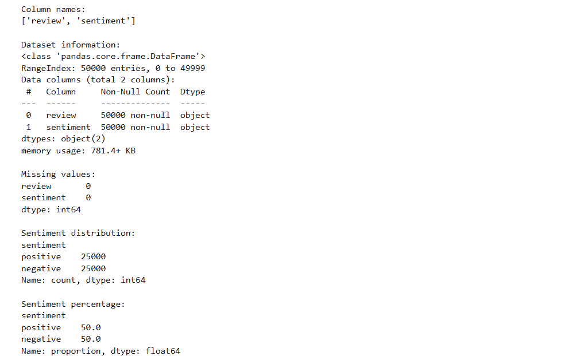
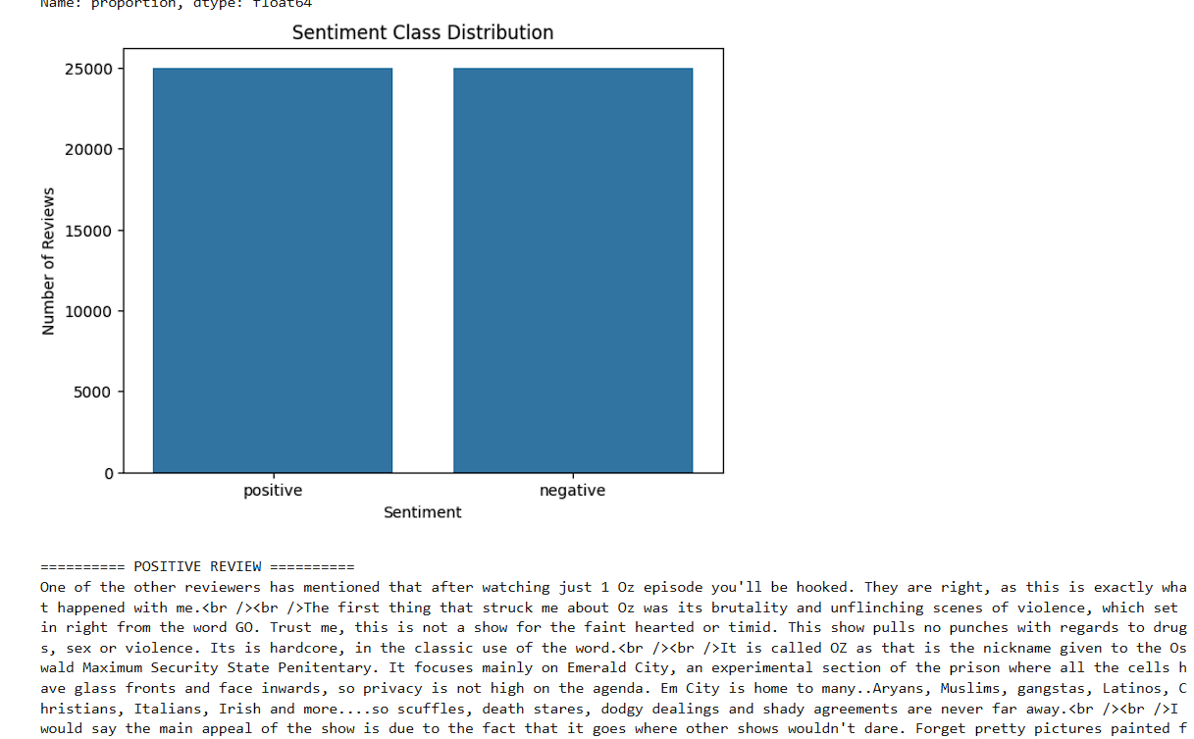
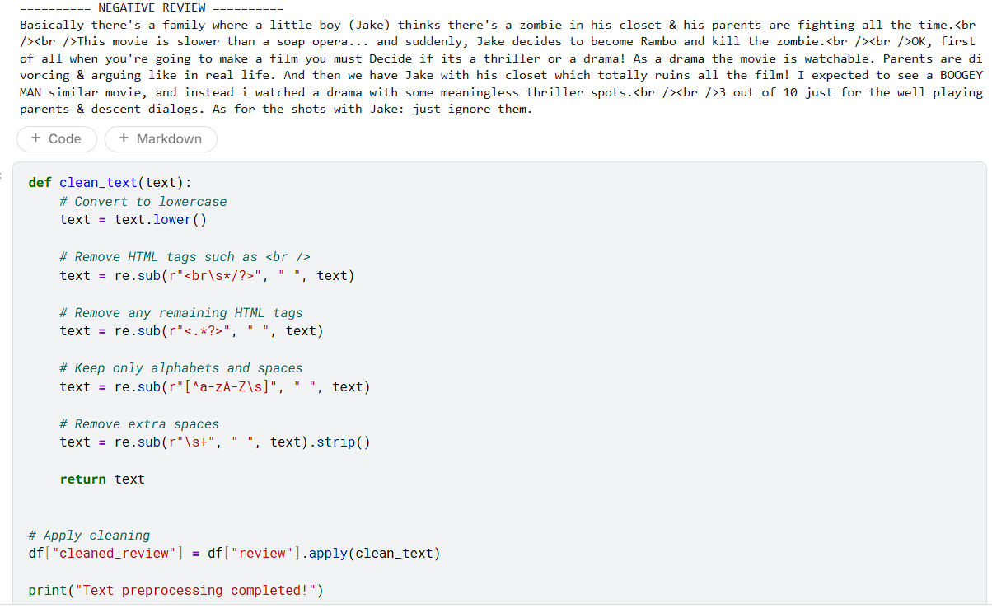
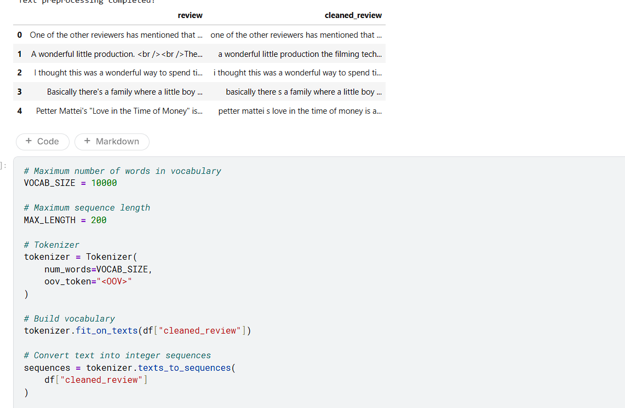
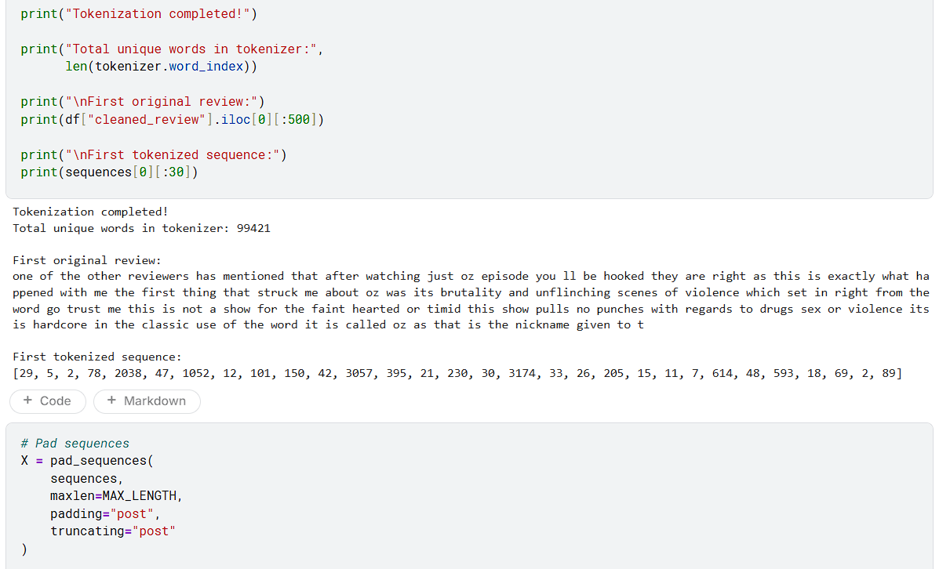
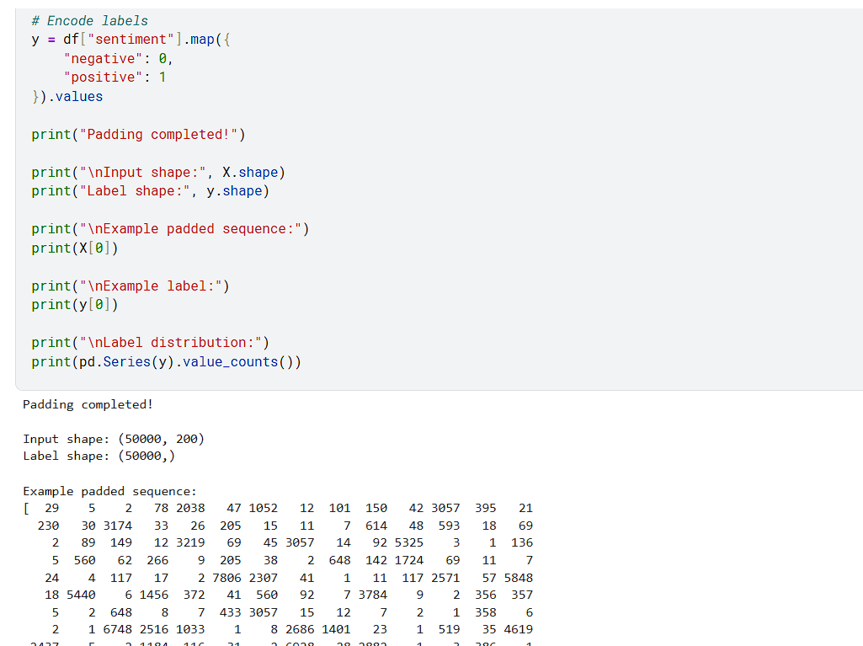
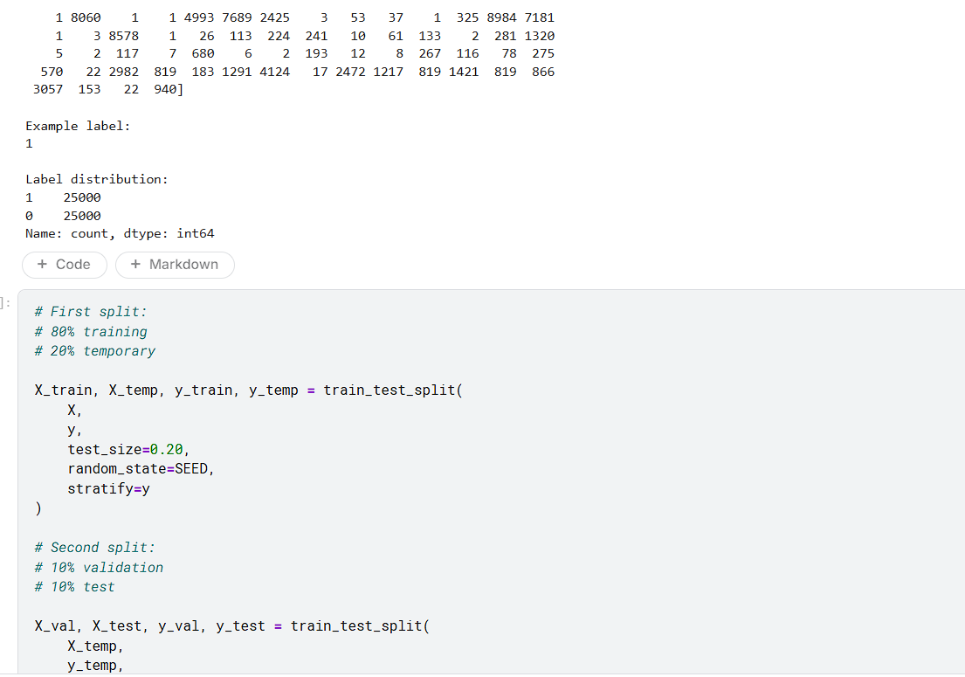
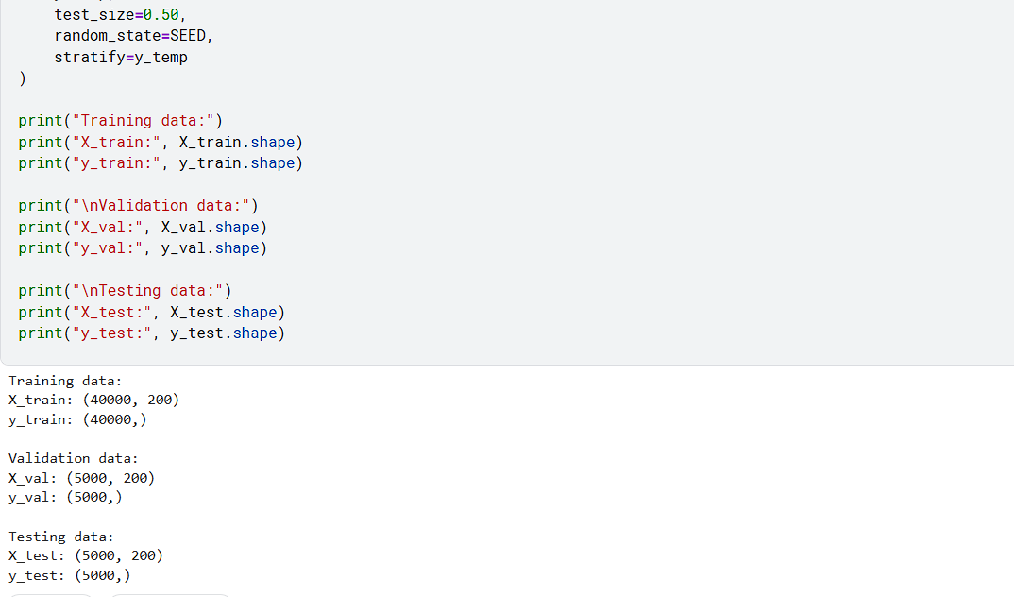
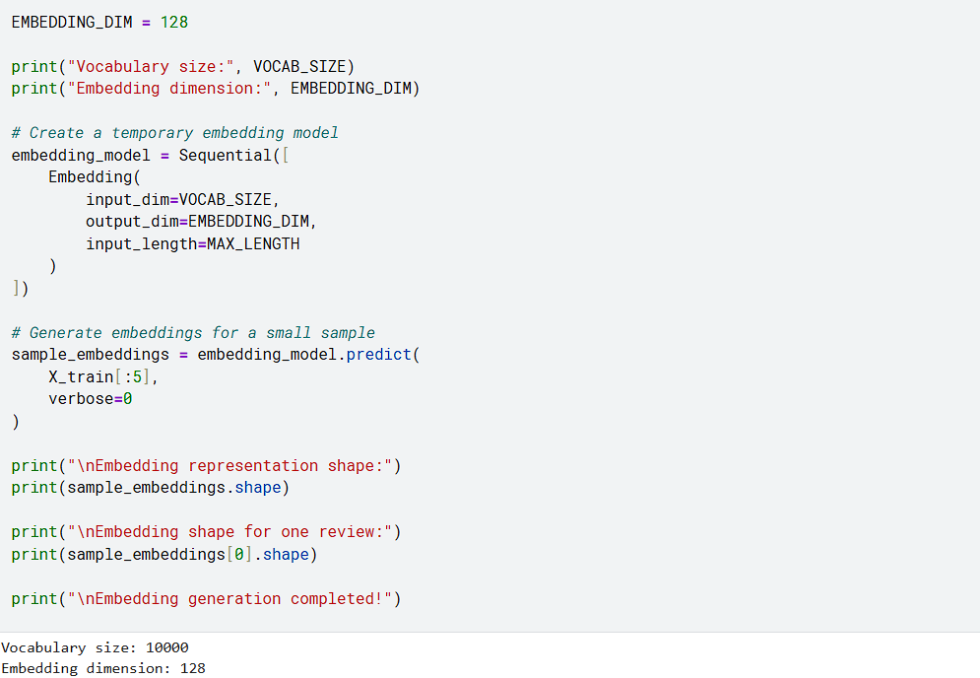
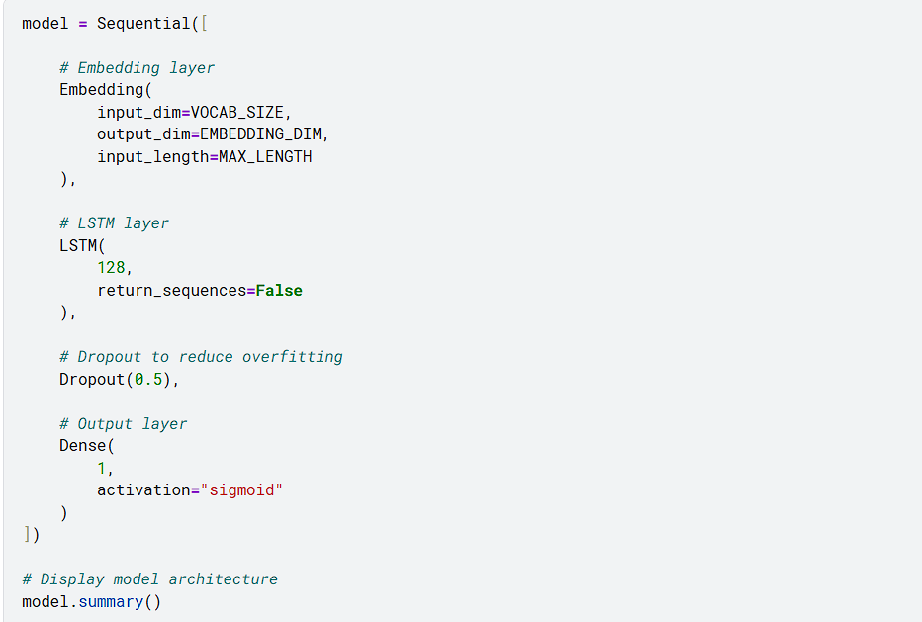
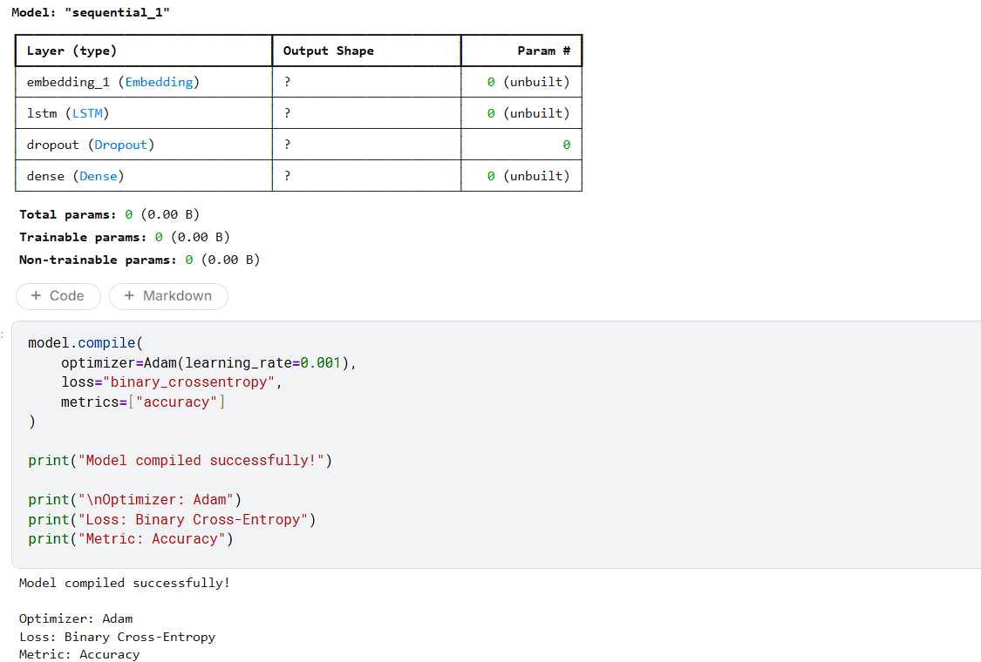
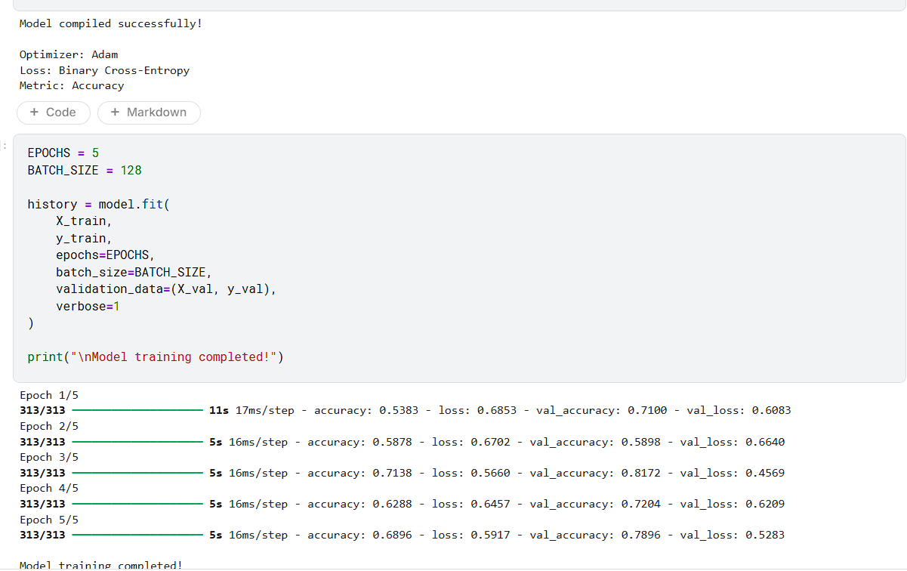
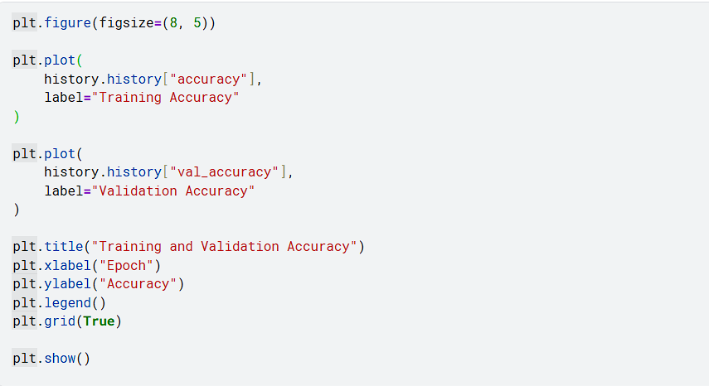
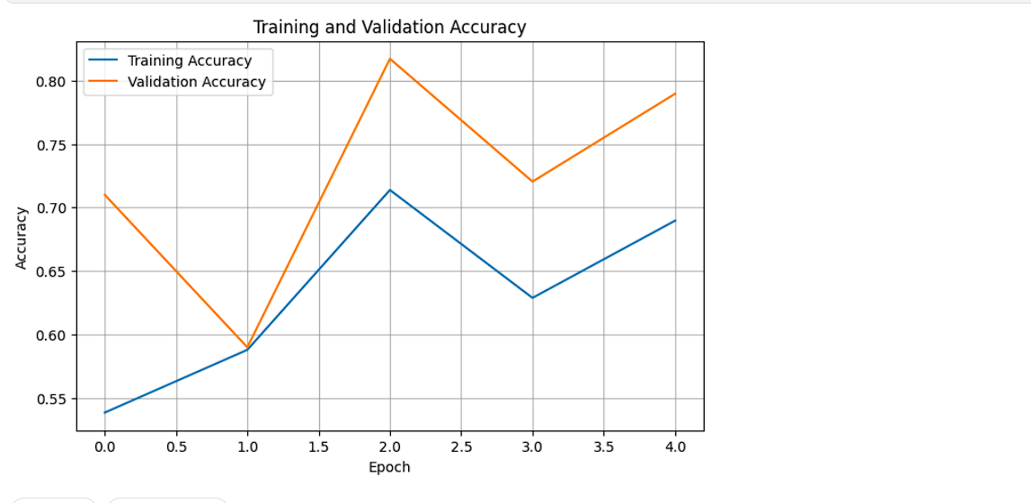
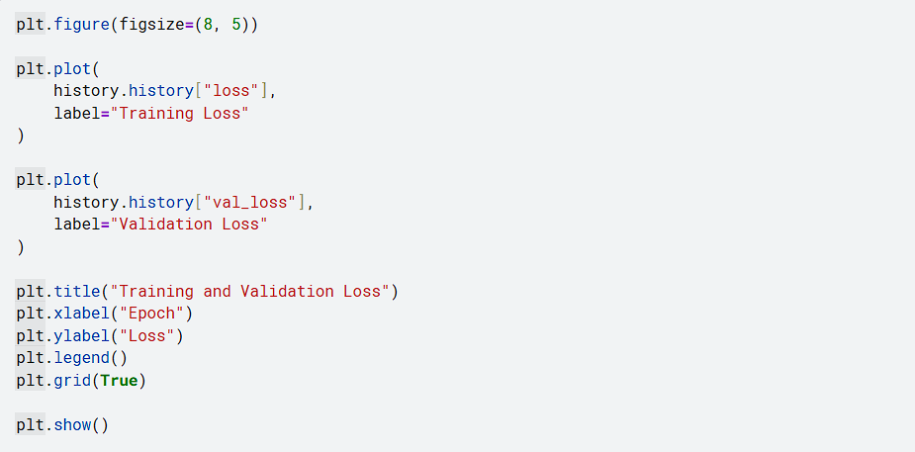
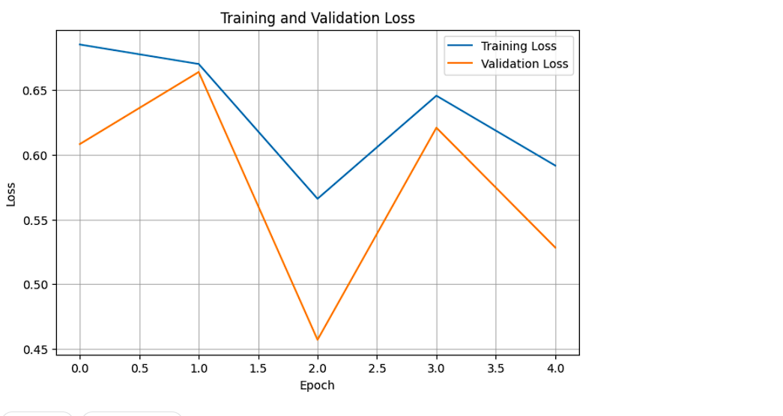
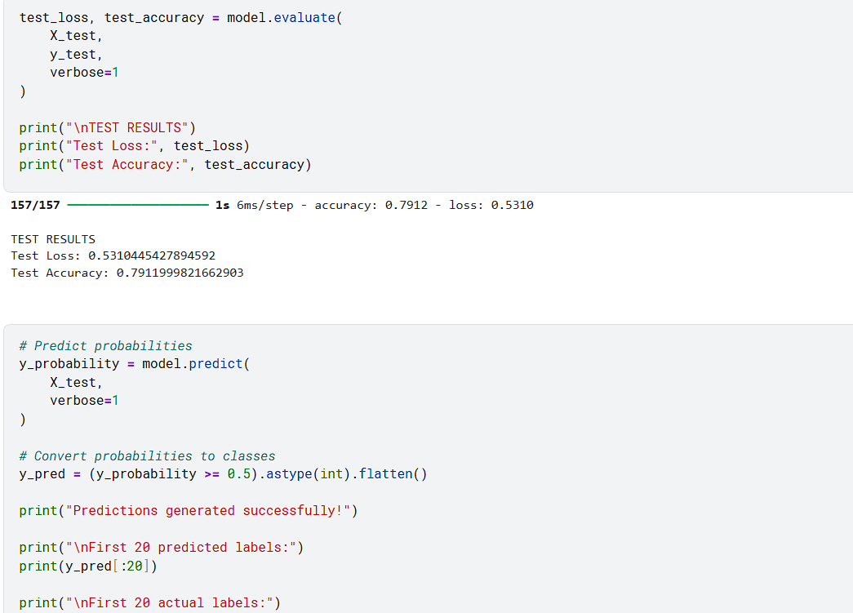
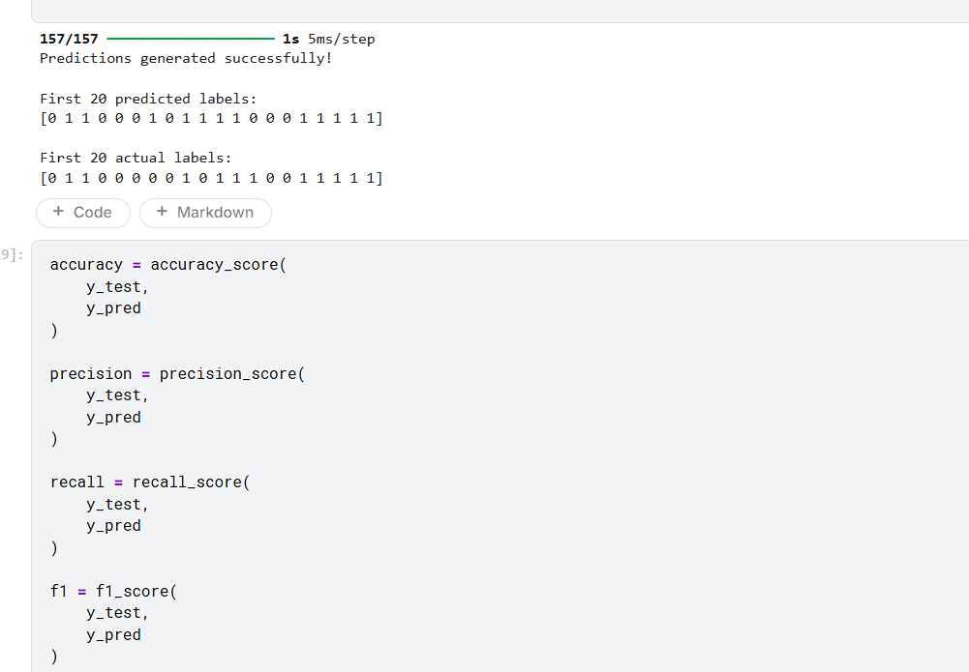
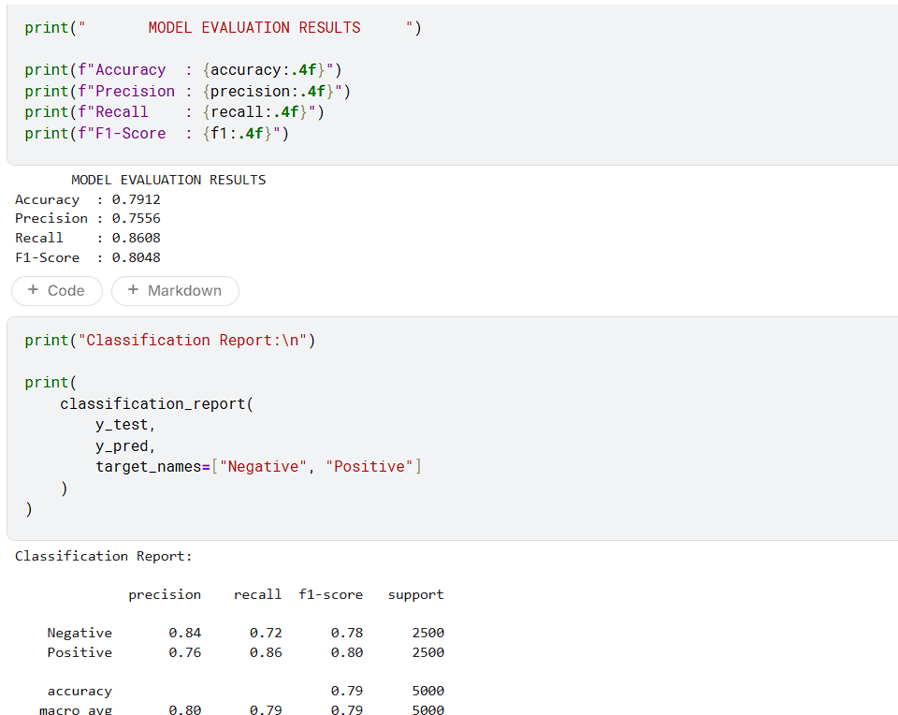
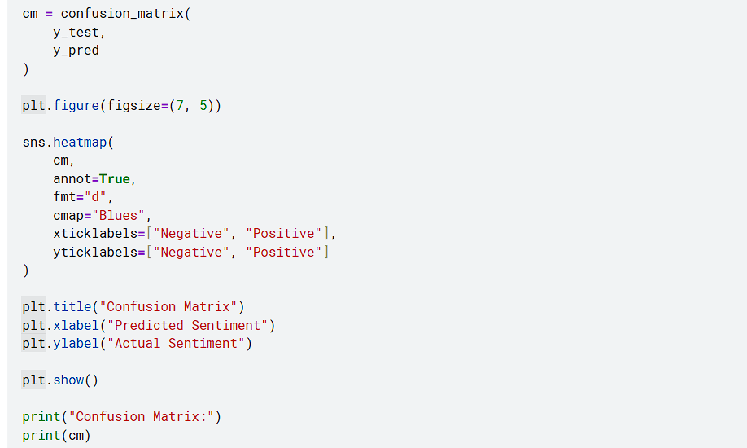
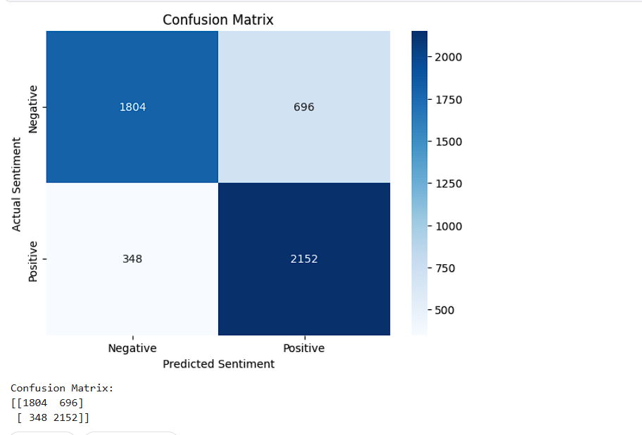
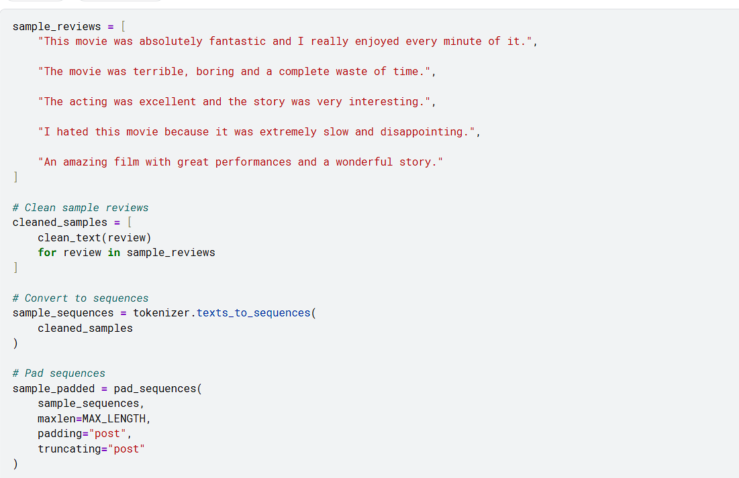
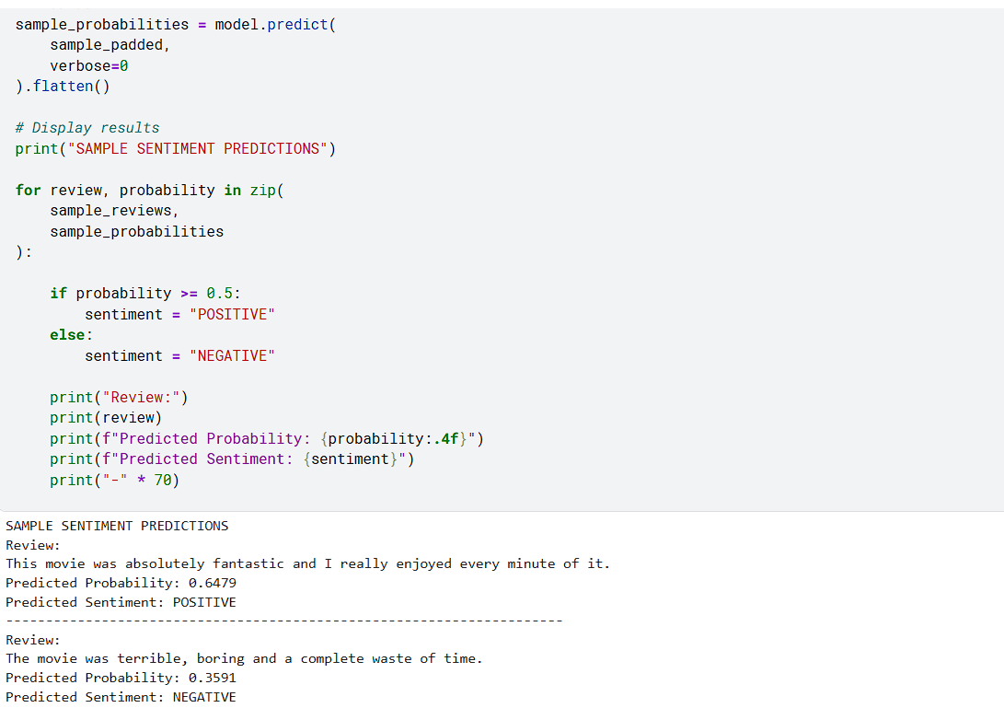
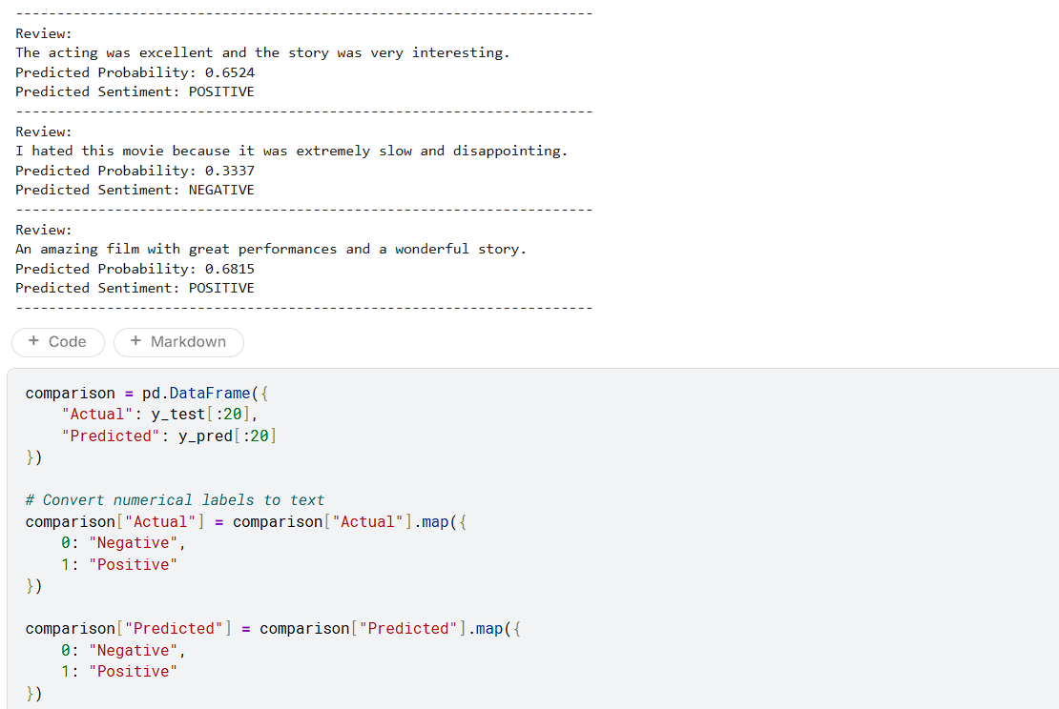
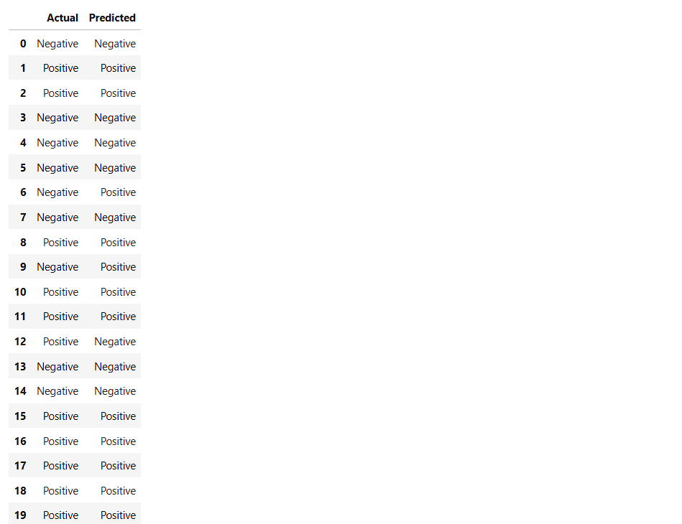
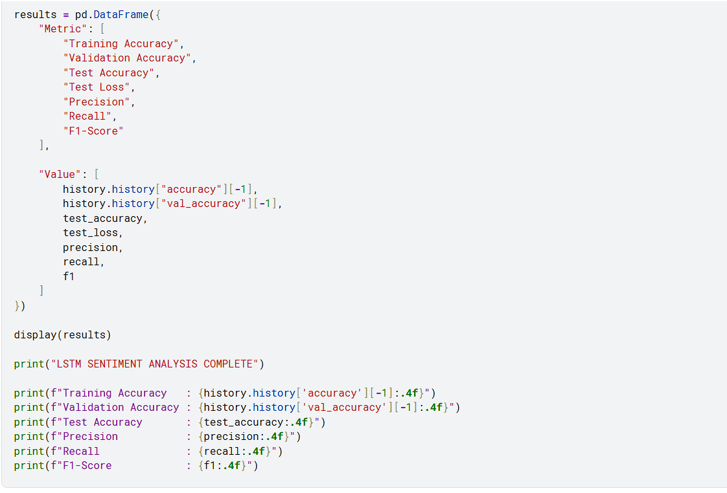
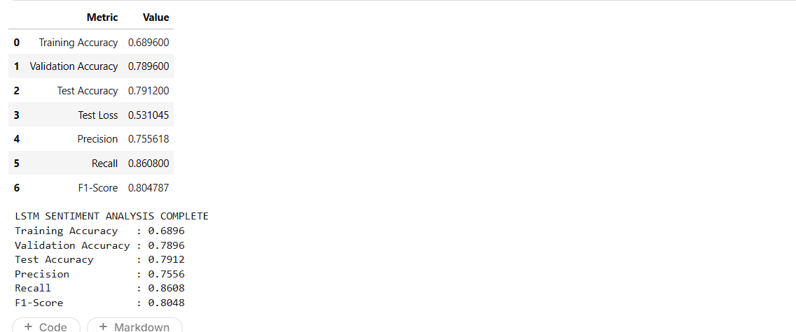

POST-LAB QUESTIONS (PROVIDE BRIEF ANSWERS TO THE FOLLOWING QUESTIONS)

- What is the role of the memory cell in an LSTM?
The memory cell is a central component of an LSTM that allows the network to store and carry important information across different steps of a sequence. It helps the model retain useful information from earlier words while processing later words. Gates regulate the information entering and leaving the memory cell. In sentiment analysis, this capability allows the LSTM to preserve relevant information from earlier parts of a review and use it when determining the overall sentiment.

- How does an LSTM overcome the vanishing gradient problem of a Simple RNN?
An LSTM reduces the vanishing gradient problem by using a memory cell and gating mechanisms that provide a more effective path for information and gradients to flow through a sequence. The gates control what information should be retained, updated, or discarded. This allows important information to remain available for longer sequences instead of gradually disappearing as in a conventional Simple RNN. As a result, LSTM networks are more suitable for learning sequential dependencies in longer text data.

- What is the purpose of the Embedding layer in the sentiment analysis model?
The Embedding layer converts numerical word or token sequences into dense vector representations. These vectors provide a more useful representation of words than simple integer values because the model can learn relationships between words during training. In the sentiment analysis model, the Embedding layer receives the padded token sequences and produces dense representations that are then processed by the LSTM layer. The experiment requires defining the vocabulary size and embedding dimension for this representation.

- How does padding affect the input to an LSTM network?
Padding makes text sequences have a common length so that they can be supplied to the LSTM network as a consistent input structure. Since reviews may contain different numbers of words, their tokenized sequences naturally have different lengths. Padding adds suitable values to shorter sequences so that all sequences have the required length. This allows the model to process a batch of reviews efficiently. The experiment specifically applies sequence padding after converting reviews into numerical sequences.

- What happens when the LSTM model is trained for too many epochs?
When an LSTM model is trained for too many epochs, it may begin to overfit the training dataset. In this situation, the model learns the specific patterns and characteristics of the training data too closely instead of learning patterns that generalize well to unseen reviews. Training accuracy may continue to improve while validation performance stops improving or decreases. Therefore, training and validation accuracy and loss should be monitored across epochs to determine suitable training duration.

- Why are precision, recall, and F1-score useful in addition to accuracy?
Precision, recall, and F1-score provide additional information about a classification model's performance beyond overall accuracy. Accuracy measures the proportion of correctly classified samples, while precision indicates how many predicted positive samples are actually positive. Recall measures how many actual positive samples are correctly identified. F1-score combines precision and recall into a single measure. These metrics are useful for understanding different types of classification errors and are included among the evaluation metrics in the experiment.
- Give one limitation of using LSTM for sentiment analysis.
One limitation of using LSTM for sentiment analysis is that it can require considerable computational resources and training time, particularly when processing large datasets and long text sequences. The model also requires several preprocessing steps, including tokenization, numerical sequence generation, padding, and embedding generation. In addition, selecting suitable model parameters such as vocabulary size, embedding dimension, and training epochs can affect performance. Therefore, although LSTM can learn sequential dependencies effectively, implementing and training it can be relatively complex.

SUGGESTIONS FOR DATASETS
- IMDB Movie Reviews – https://ai.stanford.edu/~amaas/data/sentiment/
- SST-2 (Stanford Sentiment Treebank) – https://huggingface.co/datasets/stanfordnlp/sst2
- Twitter Sentiment Analysis – https://www.kaggle.com/c/twitter-sentiment-analysis
- Stanford Sentiment Treebank (SST) – https://huggingface.co/datasets/stanfordnlp/sst
- Amazon Product Reviews – https://huggingface.co/datasets/amazon_polarity
- Yelp Polarity Reviews – https://huggingface.co/datasets/fancyzhx/yelp_polarity

ASSESSMENT
Description | Max Marks | Marks Awarded
Pre Lab Exercise | 5
In Lab Exercise | 10
Post Lab Exercise | 5
Viva | 10
Total | 30
Faculty Signature

